Lesson 1: Geometric planter: find total surface area
Standard/Benchmark:
--- G-MG.1: Use geometric shapes, their measures, and their properties to describe objects (e.g., modeling a tree trunk or a human torso as a cylinder)
--- G-CO.8: Explain how the criteria for triangle congruence (ASA, SAS, and SSS) follow from the definition of congruence in terms of rigid motions.
--- G-GMD.3: Use volume formulas for cylinders, pyramids, cones, and spheres to solve problems.
--- G-MG.3: Apply geometric methods to solve design problems (e.g., designing an object or structure to satisfy physical constraints or minimize cost; working with typographic grid systems-based ratios).
---L2.AP. M.01 Construct solutions to problems using student-created components, such as procedures, modules, and/or objects.
---L1.AP. PD.04 Design and develop computational artifacts, working in team roles, using collaborative tools.
Objectives:
Students will be able to know what is 3D printing.
Students will be able to create their own geometric planter.
Students will be able to compute the total surface area of the geometric planter they created.

Beginning Procedures: (15 minutes)
Give student a pre-test
Anticipatory set: Show students the Geometric planter poster and a short video about 3 D printing.
Explain to students that today we going to create our own geometric planter investigate polygons and find the total surface area of the polygons.

Middle Procedures: (25 minutes)
Students are to work in groups of not more them 4. Give students plastic geometry manipulative and tell them they are using the manipulative to create their own designed geometric planter and then find the total surface area of their planter.
Give students paper to write and draw their shape also write down the step they use to find the total surface area of their geometric planter they created.
Teacher walk and facilitate learning.

Ending Procedures: (25 minutes)
Have students present their geometric planter they created and the total surface area they find to the class. Ask students to explain their reason for their answer they give.
Give the students the post test.

Closing Activity: (5 minutes)

Closing activity: Have students summarize what they learn and give students exit slips.

Other Assessment:

Formative Assessment:
Interactive tool: Non-Interactive tool:
-Thumbs Ups, Thumbs Down. Written exit pass
-Think-Pair-Share Writing activities
-Numbered Heads Together Learning Log
-Verbal exit pass Homework, Class work
-Short Q&A with individual students Worksheets, quiz
Informal Observation

Scoring Guide

4 Points | The student completes the entire task independently. He/she built the figures and correctly answer all question and calculate the surface area.
3 Points | The student completes the task with some assistance. The student makes some minor errors in the question and calculation.
2 Points | The student is unable to complete the task even with assistance. He/she shows some understanding of how to but needs considerable assistance .
1 Point | The student is unable to do the task. He/she shows no understanding of the concept on hand and cannot find the total surface area.

Pertest/Post test

1. What is 3D printing?

2. What you think the 3D printing is use in today's society?

3. What is the total surface area of the below figures?

a.
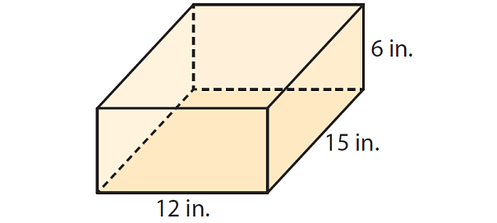

b.

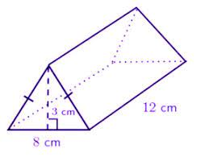

Exit Ticket:

Today I learned that____________

I may need more practice with__________

I have a question about_____________

