Impact of the Compass: Pre-test

1. Label the cardinal directions (East, South, West, North) and intermediate (Southwest, Northwest, Southeast, Northeast) on the compass rose below. You can use abbreviations if you would like.

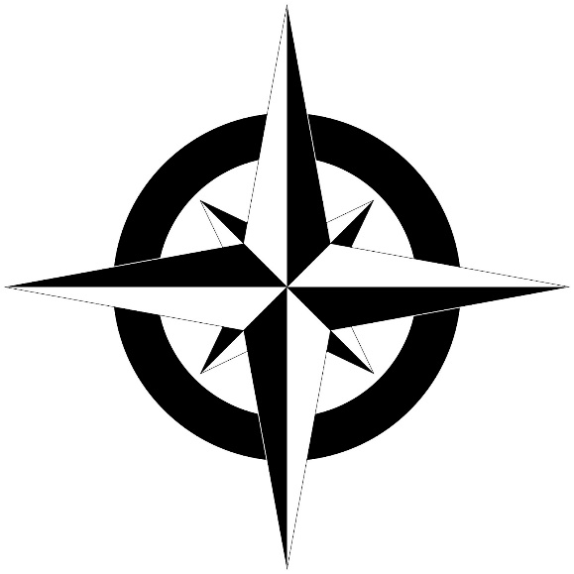

2. How does a compass work?

3. What was/is a compass used for?

4. Why is the compass such an important technological discovery/invention? Give an example of something it was used for in history.

